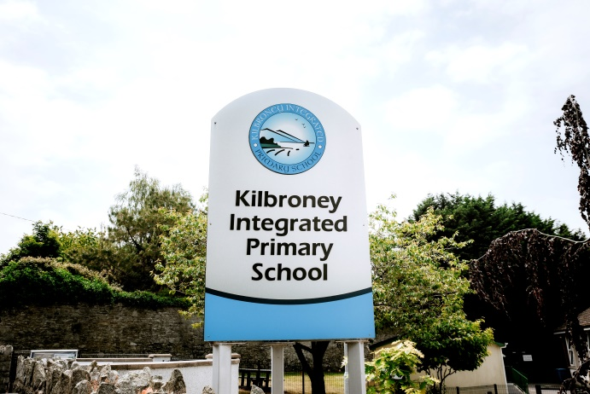
History of Kilbroney Primary school
(Source: Education in Kilbroney-A window on the Past By Robert Linden and Google)
Education in Rostrevor dates back as far as Hedge schools in the 1700’s. However throughout the 1800’s came the introduction of a variety of schools in the area:
- A school house built by Mrs Dawson and Miss Balfour in 1814 for the instruction of female children.
- Rostrevor Union School (c1821)
- The Kildare Place Society Schools- This was a society based in Dublin which was a Protestant organisation supported by government grants. Three schools under the patronage of the Kildare Place Society were established: Knockbarragh, Rostrevor and Killowen. The ruins of Knockbarragh still stand at the top of ‘The Master’s Lonan’.
- Catholic school (1828) Rev. P McEvoy
- National schools (c1836)
- Sisters of Mercy Convent for girls (1865)
- Industrial school for girls, Rostrevor (Est. prior to 1870)
- Infants School, Rostrevor (Est. PRIOR TO 1870)
- St Mary’s Boys School (1889)
The Convent of Mercy school and St Mary’s Boys school amalgamated in September 2006 to form St. Bronach’s P.S.

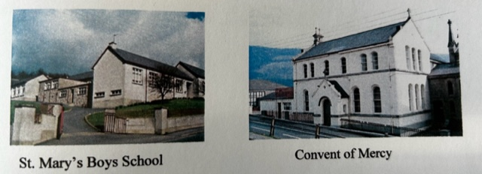

Kilbroney (established 1828) is one of the only early schools to have survived from that period of history.

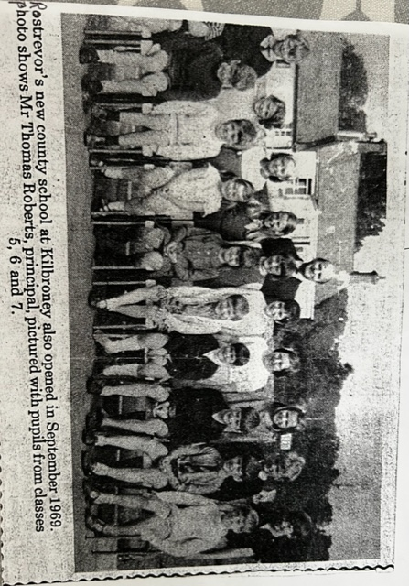
Early Church School in Rostrevor
Prior to the late 1840’s an early Church of Ireland School (Parish of Kilbroney) occupied the building beside ‘Benvenue’ on the Kilbroney Road, which was later known as the School Master’s Residence. Mr Thomas Roberts was the last Principal to live there and he went on to purchase the property. This old school was the forerunner to the present Kilbroney Integrated PS.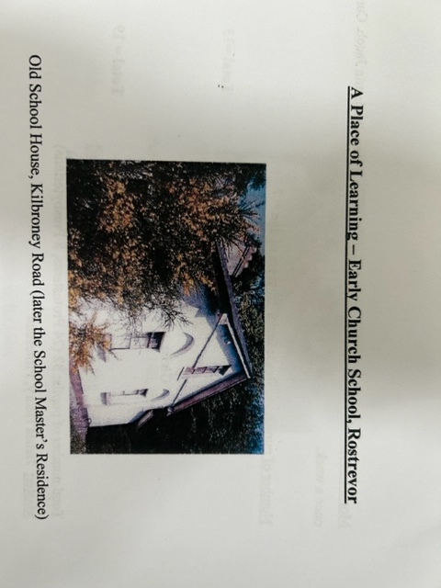

Kilbroney Church of Ireland School
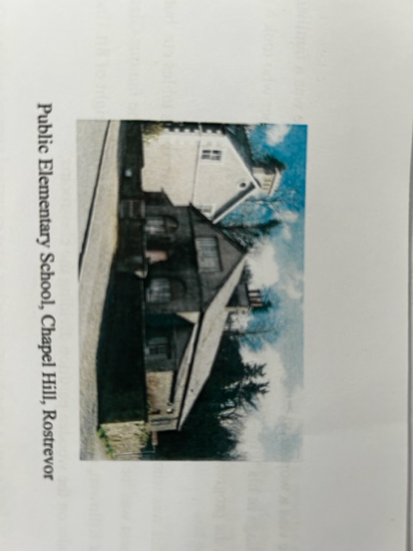
In the mid 1840’s an application was made for a site at Chapel Hill, Rostrevor, on which to build a new school building. The plot of ground was sold on 14th March 1846 from the Ross Estate and was erected shortly afterwards and completed in 1847. The school was known as ‘Kilbroney Public Elementary School’.

It was in 1956 that the school was transferred to the Education Authority (N.I.) and then became known as Kilbroney Primary School. The school consisted of two spacious classrooms and a caretakers residence at the front. The toilets were outside and the playground was at the back of the building. The class teacher of the junior classes was a Miss Annie Davis from Belfast and the Principal was Mr Joseph Purdy from Annalong.

Mr David Graham from Lurgan took on the role of Principal after Mr Purdy’s retirement. Subjects taught in the school included: English, Arithmetic, Geography, Algebra, Art, Music, Nature Studies and Religion.

New school building
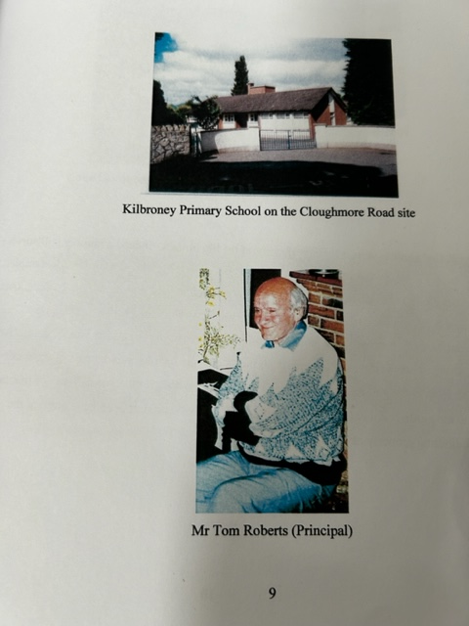
With the passing of time the school on Chapel Hill became outdated and so a new school building was required. The new school opened in September 1969 and was built within a large walled garden beside Syenite Place on the Cloughmore Road and cost £45,000. In the evenings it opened its doors to Further Education students as an outreach centre.

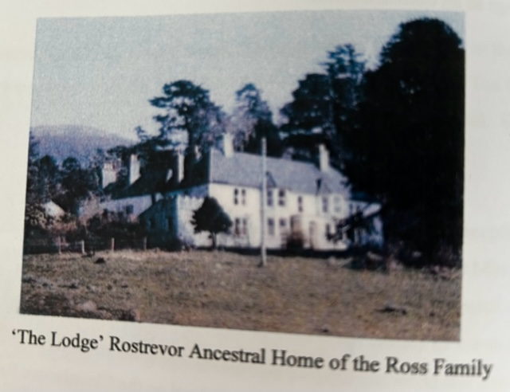
The Walled Garden Site

The walled garden originally belonged to ‘The Lodge’, the ancestral home of the Ross family in Rostrevor. The Lodge Demense was known as ‘The Lyon Estate’ prior to purchase by Newry and Mourne Council in 1977 (now Kilbroney Park). The original and historic old house was demolished in 1980.

Kilbroney Integrated Primary School
As seen in the report by the Newry Reporter on Thursday 15th October 1998, the school was granted controlled integrated status by the Southern Education and Library Board. At this time, the school was also given extra teaching hours and so employed a fourth member of staff. The bid to transform to Integrated Status was a long 18 month campaign in which both parents, Board of Governors, Principal Mrs Jane Coffey and staff made an application to the SELB and created a Development Proposal which was then approved.

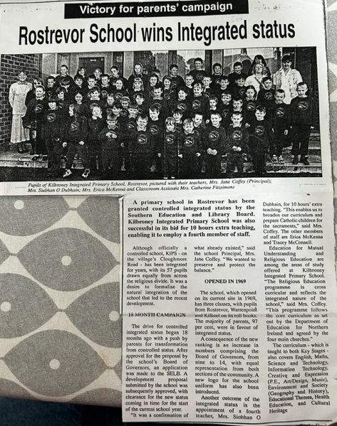
The school which had opened in the walled garden site in 1969 consisted of three classrooms. Since then the school has benefited from three major extensions, in 2009 additional classrooms were added, in 2013 a new hall was gained with a further extension added in 2017. The school currently has five classrooms in the main building, a resource area, and ICT suite, repographics room plus a mobile classroom within the grounds. There is a large playground at the back of the building, an outdoor learning and play area for KS1, a community garden plus a forest area for KS2. The school also enjoys easy access to all the wonderful grounds and facilities at Kilbroney Park.
