Anti Bullying Policy
  - Kilbroney Integrated Primary School

Date: __________________________________

Chair of Governors: _________________________

Review: _(4 years time)_______________________________

Contents
Mission Statement: 3
ETHOS 3
Section 2 – Context 3
CONTEXT: KEY LEGISLATION: DUTIES PLACED ON BOARDS OF GOVERNORS 4
Section 3 – Ethos & Principles 5
Section 4 – Consultation and Participation 6
Section 5 – What is Bullying? 7
Section 6 – Preventative Measures 10
The School’s View 10
Section 7 – Responsibility 15
Section 8 – Reporting a Bullying Concern 16
Section 9 – Responding to a Bullying Concern 17
SUPPORT PROVISIONS 18
Section 10 – Recording 20
Section 11 – Professional Development of Staff 21
Section 12 – Monitoring and Review of Policy 22
Section 13 – Links to Other Policies 22
Appendix 1 24
Appendix 2 35
Appendix 3 Intervention tables NIABF 36
Appendix 4 38
Appendix 5 Consultation documents 45
Anti Bullying Pupil Consultation P.1-3 45
Anti Bullying Pupil Consultation P.4-7 46
Anti Bullying Parent/Guardian Consultation 48
Results of Parent Consultation 49
Anti Bullying Parent/Guardian Consultation 49
Given to Parents on 25/10/23 49
50
Kilbroney Integrated PRIMARY SCHOOL 50

This policy has been developed within the context of current legislation, policy and guidelines:

Mission Statement:

ETHOS
A statement and evaluation of the ethos of Kilbroney Integrated Primary School.
‘Learning from each other’
'Kilbroney IPS is open to pupils of any religious denomination or of none. We are a Christian based school which creates an environment where those of all faiths and none are respected, acknowledged and accepted as valued members of our school community.'
We at Kilbroney Integrated Primary School aim to provide a happy and caring atmosphere for the child, where they feel secure and able to fulfil their potential. We will acknowledge and celebrate their achievements and individual strengths and differences and aim to promote their self-esteem and confidence at all times.

Our purpose is to provide a solid foundation to help them to progress to adulthood through:
- Encouraging each child to be confident, independent and responsible learners through a curriculum which suits the needs of each individual.
- Promoting the development of lively and enquiring minds to acquire skills towards self-learning.
- Developing respect for others in terms of religion, race and personal circumstances and
- Encouraging the children to become active and interested members of the wider community.

At Kilbroney Integrated P.S we believe all forms of bullying behaviour are unacceptable. We believe that all pupils have the right to learn in a safe and supported environment.
We as a school community repudiates bullying behaviour of any kind, to any member of the school community, by any member of the school community.

Section 2 – Context
This policy is informed and guided by current legislation and DE Guidance listed below:
The Legislative Context:
- The Addressing Bullying in Schools Act (Northern Ireland) 2016
- The Education and Libraries Order (Northern Ireland) 2003 (A17-19)
- The Education (School Development Plans) Regulations (Northern Ireland) 2010
- The Children (Northern Ireland) Order 1995
- The Human Rights Act 1998
- The Health and Safety at Work Order (Northern Ireland) 1978
The Policy & Guidance Context
- The Addressing Bullying in Schools Act (Northern Ireland) 2016 Statutory Guidance for Schools and Boards of Governors (DE, 2019)
- Pastoral Care in School: Promoting Positive Behaviour (DE, 2001)
- Safeguarding and Child Protection in Schools: A Guide for Schools (DE, 2017)
  - Co-operating to Safeguard Children and Young People in Northern Ireland (Dept. of Health, Social Services and Public Safety, 2016)
  - Safeguarding Board for Northern Ireland Policies and Procedures (SBNI, 2017)

The International Context
- United Nations Convention on the Rights of the Child (UNCRC)

CONTEXT: KEY LEGISLATION: DUTIES PLACED ON BOARDS OF GOVERNORS
- Addressing Bullying in Schools Act (Northern Ireland) 2016
- Duty of Board of Governors to secure measures to prevent bullying.
- Duty to keep a record of incidents of all incidents of bullying or alleged bullying involving a registered pupil at the school.

2. WELFARE AND PROTECTION OF PUPILS EDUCATION AND LIBRARIES (NORTHERN IRELAND) ORDER 2003 - DE Circular Number 2003/13 - which amends Article 3 of 1998 N.I. Order as follows:

Article 17 DUTY TO SAFEGUARD AND PROMOTE THE WELFARE OF PUPILS
The Board of Governors is required to:
- “safeguard and promote the welfare of all registered pupils whether they are on the school premises or elsewhere while in the lawful control or charge of a member of staff of the school” (Article 17: 2)
- consult with registered pupils on the general principles which will be reflected in the school’s discipline policy (Article 19: 13 & 14)

The Principal
- when deciding on measures which will be used to encourage good behaviour in the school must specifically include measures to prevent bullying among pupils (Article 19:14)
- before deciding on measures to encourage good behaviour must consult with pupils registered at the school and their parents” (Article 19:14)

The key points to note are:
- The Addressing Bullying in Schools Act (Northern Ireland) 2016:
  - Provides a legal definition of bullying.
  - Places a duty on the Board of Governors to put in place measures to prevent bullying behaviour, in consultation with pupils and parents.
  - Requires schools to record all incidents of bullying behaviour and alleged bullying incidents.
  - Sets out under which circumstances this policy should be applied, namely:
    - In school, during the school day
    - While travelling to and from school
    - When under control of school staff, but away from school (e.g. school trip)
    - When receiving education organised by school but happening elsewhere (e.g. in another school in the ALC)
  - Requires that the policy be updated at least every four years.
- The Education and Libraries Order (NI) 2003, requires the Board of Governors to:
  - ‘Safeguard and promote the welfare of registered pupils’ (A.17)
- The United Nations Convention on the Rights of the Child (UNCRC) sets out every child’s right to:
  - Be protected from all forms of physical or mental violence, injury or abuse, maltreatment or exploitation. (A.19)
  - Be protected from discrimination. (A.2)
  - Express their views, in a supported and accessible way, on issues that affect them, and to have their opinions taken seriously. (A.12)
  - Education. (A.28)

Section 3 – Ethos & Principles
Every effort is made to encourage the children to see the importance of good behaviour and manners, respect and consideration of others in creating a happy, safe and secure learning environment for all.
Our anti-bullying policy is based on establishing good relationships between staff, staff and pupils and between the pupils themselves. Relationships between home and school play an essential part in the success of our policy, as parental awareness and support of the anti-bullying policy is vital in supporting the mechanisms in place at school. Our policy incorporates: -
- Ethos and values
- Relationships and attitudes
- Policies, procedures and practices
- Internal and external support structures

We, the governors and staff of Kilbroney Integrated Primary School, believe that the school is a vital part of our community.

- We are committed to a society where children and young people can live free and safe from bullying.
- We believe in a society where bullying is unacceptable and where every child and young person is safe and feels safe from bullying.
- We believe that every child and young person should be celebrated in their diversity.
- We are committed to a preventative, responsive and restorative anti-bullying ethos across the whole school.
- We value the views and contributions of children and young people; we will actively seek these views and we will respect and take them into account.
- We understand that everyone in our school community has a role to play in taking a stand against bullying and creating a safe and welcoming environment for all.

Section 4 – Consultation and Participation
This policy is subject to consultation which will be carried out in line with whole school.
development planning consultation to pupils, parents, staff and governors in the form of an online survey on a three-year cycle.

The anti-bullying policy may be subject to interim review if required.

Pupil Voice will feed into consultation and ongoing anti-bullying messaging through the involvement of the pupil council and through whole school pastoral provision.

Draft copy of the policy will be published on the school website, school stakeholders will be furnished with a link by email and social media and invited to provide comment on the policy ahead of amendment and approval by the school’s board of governors.
This policy has been developed in compliance with the Addressing Bullying in Schools Act (NI) 2016.
Pupils will be consulted through:
- Consultative workshops with pupils
- Class-based activities
- Whole school questionnaires distributed to all pupils.
- Creation of a reference group of pupils, e.g. the School Council
Consultation with parents/carers will be through:
- Information sent home with parents/carers in relation to the draft policy.
- Parents have a designated time frame to respond to the policy.
- Questionnaires distributed to all parents/carers (online/paper)
- Final Policy agreed with Board of Governors and added to the school website.
The school will also consult with all members of the school community when developing or reviewing this policy. This includes:
- Staff survey for all staff, teaching and non-teaching.
- Engagement activity for all staff, teaching and non-teaching.
- Representative members of staff involved in writing anti-bullying policy.
- Engagement event, or questionnaires, for those connected to the school (e.g. local clergy, local supporters, external agencies that regularly provide input, etc.)

Section 5 – What is Bullying?
What is meant by the term ‘bullying’.
The Addressing Bullying in Schools Act (NI) 2016 provides schools with a legal definition.
Addressing Bullying in Schools Definition of “bullying”:
1.— (1) In this Act “bullying” includes (but is not limited to) the repeated use
of—
(a) any verbal, written or electronic communication,
(b) any other act, or
(c) any combination of those, by a pupil or a group of pupils against another pupil or group of pupils, with the intention of causing physical or emotional harm to that pupil or group of pupils.
(2) For the purposes of subsection (1), “act” includes omission.
A statement on the definition can be seen below:
Bullying is behaviour that is usually repeated, which is carried out intentionally to cause hurt, harm or to adversely affect the rights and needs of another or others.
While bullying is usually repeated behaviour, there are instances of one-off incidents that the school will consider as bullying.
When assessing a one-off incident, to make a decision on whether to classify it as bullying, the school shall consider the following criteria:
- severity and significance of the incident
- evidence of pre-meditation
- impact of the incident on individuals (physical/emotional)
- impact of the incidents on wider school community
- previous relationships between those involved.
- any previous incidents involving the individuals.
Any incidents which are not considered bullying behaviour will be addressed under the Positive Behaviour Policy.

The following unacceptable behaviours, when repeated, targeted and intentionally hurtful, may be considered a bullying behaviour:
- Verbal or written acts
  - saying mean and hurtful things to, or about, others
  - making fun of others
  - calling another pupil mean and hurtful names.
  - telling lies or spread false rumours about others.
  - try to make other pupils dislike another pupil/s.
- Physical acts
  - Hitting
  - kicking
  - pushing
  - shoving
  - material harm, such as taking/stealing money or possessions or causing damage to possessions.
- Omission (Exclusion)
  - Leaving someone out of a game
  - Refusing to include someone in group work.
- Electronic Acts
  - Using online platforms or other electronic communication to carry out many of the written acts noted above.
  - Impersonating someone online to cause hurt.
  - Sharing images (e.g. photographs or videos) online to embarrass someone

We must stress that the above list is not exhaustive and that other behaviours which fit with the definition may be considered bullying behaviour.
There may be various motivations behind bullying incidents, including those named in the Act. These include, but are not limited to:

- Age
- Appearance
- Breakdown in peer relationships
- Community background
- Political affiliation
- Gender identity
- Sexual orientation
- Pregnancy
- Marital status
- Race
- Religion
- Disability / SEN
- Ability
- Looked After Child status.
- Young Carer status
Bullying is an emotive issue; therefore it is essential that we ensure we use supportive, understanding language when discussion these matters. For that reason, we will not refer to a child as ‘a bully’, nor will we refer to a child as ‘a victim’. Instead, we will refer to the child describing the situation surrounding that child, for example:
- A child displaying bullying behaviours.
- A child experiencing bullying behaviours.
We encourage all members of the school community to use this language when discussion bullying incidents.
In determining ‘harm’ we define:
- Emotional or psychological harm as intentionally causing distress or anxiety by scaring, humiliating or affecting adversely a pupil’s self-esteem.
- Physical harm as intentionally hurting a pupil by causing injuries such as bruises, broken bones, burns or cuts.

Section 6 – Preventative Measures
Rationale
If children are to make progress in their education, the environment for learning should be safe and caring. Every child has the right to:
- Be educated in a safe secure environment where their moral, intellectual, personal and social development is promoted.
- Their parents and carers being informed and re-assured that their children are being educated in a safe, caring and respectful atmosphere.

The School’s View
We believe that bullying behaviour is a highly distressing and damaging form of abuse and is not tolerated in our school. It is entirely contrary to the values and principles we work and live by. All members of the school community have a right to work in a secure and caring environment. They also have a responsibility to contribute, in whatever way they can, to the protection and maintenance of such an environment. It is our aim to promote a strong anti-bullying ethos within the school and the wider school community.
Staff are vigilant at all times to the possibility of bullying behaviour occurring and take preventative steps to stop it happening and immediate action if an incident of bullying behaviour occurs, in order to protect, reassure and support the children involved. Parents will be contacted when bullying behaviour is identified.
The main areas when focusing on bullying are: -
- Policy and procedure
- Training and resources
- Curriculum and classroom practices
- School ethos

Under the revised legislation, the main focus for this anti-bullying policy is prevention.
We are committed to identifying Bullying pre-emptively when possible and to promoting.
and maintaining a Listening and Telling Culture.

In Kilbroney Integrated PS we will be consistent in the implementation of the Positive Behaviour Policy which:
- upholds everyone’s right to be safe both physically and emotionally and requires everyone to behave in ways which keep everyone else safe – both physically and emotionally at all times towards others
- bullying behaviour of any kind by any member of our school community to any other member of our community is completely unacceptable.
- requires high standards of behaviour at all times from every member of the school community.
promotes early intervention and provides tailored support for those young people who experience difficulty in meeting acceptable standards of behaviour.
- acknowledges and affirms positive behaviours.
- acknowledges and sanctions socially unacceptable behaviours.
- carries out regular school audits to assess the effectiveness of the policy through, for example, monitoring levels of pupil/staff wellbeing & relationships.

In Kilbroney Integrated PS we will be consistent in the delivery of pastoral/preventative curriculum which:
- addresses issues such as bullying, sectarianism, racism, and good relations through PDMU/ PD/ LLW
- through the preventative curriculum (taught pastoral/preventative curriculum) actively promotes positive emotional health and wellbeing and reduce likelihood of ‘cyberbullying’
- develops emotional literacy, interpersonal and intrapersonal skills through for example planned Circle Time sessions.
- builds confidence, self-esteem and resilience.
In Kilbroney Integrated PS we will use ongoing tracking and monitoring of supervision arrangements re canteen, playground, corridors, toilets through for example:
- use of emotional mapping to identify ‘hotspots and audit supervision needs
- provision of Safe Havens to support vulnerable pupils e.g., through seating arrangements, movement between classes, providing peer support arrangements including Circle of Friends:
- provision of friendship stops/benches, suggestion boxes, playground buddy systems, peer mentoring.

In Kilbroney Integrated PS we will encourage active whole-school participation in NIABF’s Anti-Bullying Week activities

In Kilbroney Integrated PS we will encourage active involvement of the School Council in for example the development of:
- pupil agreed Codes of Behaviour such as AUPs, class/bus /visits charters.
- ‘Keeping safe’ messages
- pupil aide memoires
- audits which track and monitor emotional wellbeing.
Every member of the school community – pupils, parents, carers, staff (T/NT), Governors - will be expected to work collaboratively together to:
- foster positive self-esteem; respect the right of others to be safe.
- behave towards others in a mutually respectful way.
- model high standards of personal pro-social behaviour
- be alert to signs of distress* and other possible indications of bullying behaviour.
- inform the school of any concerns relating to bullying behaviours.
- refrain from becoming involved in any kind of bullying behaviour, even at the risk of incurring temporary unpopularity.
- refrain from retaliating to any form of bullying behaviour.
- intervene to support any person who is being bullied, unless it is unsafe to do so.
- report any concerns or instances of bullying behaviour witnessed or suspected, to a member of staff.
- emphasise the importance of telling a trusted person about bullying behaviour when it happens or is observed.
- explain the implications of allowing the bullying behaviour to continue unchecked, for themselves and/or others.
- listen sensitively to anyone who has been bullied, take what is said seriously, and provide reassurance that appropriate action will be taken.
- know how to seek support – internal and external.
- resolve difficulties in restorative ways to prevent recurring bullying behaviour and meet the needs of all parties.
This Anti-Bullying Policy recognises that within schools there is a continuum of socially unacceptable behaviours. These unacceptable socially unacceptable behaviours infringe on everyone’s right to be safe. They include the following examples:
- Physical - includes jostling, physical intimidation, punching/kicking, any other physical contact which may include use of weapons.
- Verbal - includes name calling, insults, jokes, threats, spreading rumours.
- Indirect - includes isolation, refusal to work with/talk to/play with/help others, interfering with personal property and includes cyber-bullying: misuse of mobile phones and internet programmes to humiliate, threaten and/or isolate another.

In Kilbroney Integrated PS all socially unacceptable behaviours will be dealt with in line with the school’s Positive Behaviour Policy’s procedures.
Here in Kilbroney Integrated PS we will differentiate between socially unacceptable behaviours and those which do constitute bullying behaviours. Socially unacceptable behaviours BECOME BULLYING BEHAVIOURS when the information gathered clearly demonstrates that the unacceptable behaviour DOES MEET THE CRITERIA LISTED BELOW i.e., on the basis of the evidence gathered the behaviour is/was:
- intentional,
- targeted at a specific pupil or group of pupils.
- repeated*
- causing physical or emotional harm
- omission

In order to prevent bullying behaviours Kilbroney Integrated school have set out a number of key actions that will be taken forward, with the aim of preventing bullying and creating a safe learning environment. Examples of these include:
- Raising awareness and understanding of the positive behaviour expectations, as set out in the Positive Behaviour Policy
- Promotion of anti-bullying messages through the curriculum e.g. inclusion of age-appropriate material specific to individual subject areas related to bullying, positive behaviour and inclusion
- Addressing issues such as the various forms of bullying, including the how and why it can happen, through PDMU/PD/LLW (e.g. sectarian, racist, homophobic, transphobic, disablist, etc.)
- Involvement in meaningful and supportive shared education projects, supporting pupils to explore, understand and respond to difference and diversity.
- Through the preventative curriculum actively promote positive emotional health and wellbeing (e.g. mindfulness training)
- Participation in the NIABF annual Anti-Bullying Week activities
- Engagement in key national and regional campaigns, e.g., Safer Internet Day, Good Relations Week, etc.
- Development of peer-led systems (e.g. School Council) to support the delivery and promotion of key anti-bullying messaging within the school
- Development of effective strategies for playground management, e.g. training for supervisors, zoning of playgrounds, inclusion of specific resources (buddy benches, play bus stops) and provision of a variety of play options to meet the needs of all pupils.
- Focused assemblies to raise awareness and promote understanding of key issues related to bullying.
- Development of effective strategies for the management of unstructured times (e.g. break time, lunch)
- Provision and promotion of extra- and co-curricular activities, aimed at supporting the development of effective peer support relationships and networks. For example, sporting activity, creative arts, leisure and games, etc.
Under the new legislation, schools must state within their policy the preventative measures they will put in place to prevent bullying behaviour on the way to and from school. While many of the measures outlined above will support the development of an anti-bullying culture, there are a number of ways schools can further build upon this related specifically on the journey to and from school. This includes:
- Development of a culture where pupils take pride in their school and are viewed as ambassadors for their school within the community. This includes regular reminders of the positive behaviour expectations of pupils whilst travelling to and from school.
- Measures to empower pupils to challenge inappropriate and unacceptable behaviour of their peers during the journey to and from school. This may include the implementation of peer monitoring systems on buses, trains and ferries, and for those walking.
- Regular engagement with transport providers (e.g. Translink, EA Transport, etc.) to ensure effective communication and the early identification of any concerns.
- Promotion of key anti-bullying messages and awareness of behaviour expectations of pupils amongst the local community (e.g. local shops, cafes, service providers, residents, etc), including information on how to raise any concerns with the school.
- Appropriate deployment of staff to support the transition from school day to journey home (e.g. staff duty at school gate/bus stops, where appropriate)

The new legislation also gives schools the authority to take steps to prevent bullying through the use of electronic communication amongst pupils at any time during term, where that behaviour is likely to have a detrimental effect on the pupil’s education at school. In Kilbroney Integrated P.S we will take steps to raise awareness of the nature and impact of online bullying and support our pupils to make use of the internet in a safe, responsible and respectful way. This may include:
- Addressing key themes of online behaviour and risk through PDMU/PD/LLW, including understanding how to respond to harm and the consequences of inappropriate use.
- Participation in Anti-Bullying Week activities.
- Engagement with key statutory and voluntary sector agencies (e.g. C2k, PSNI, Public Health Agency, Safeguarding Board for NI e-Safety Forum) to support the promotion of key messages.
- Participation in annual Safer Internet Day and promotion of key messages throughout the year.
- Development and implementation of robust and appropriate policies in related areas (e.g. Acceptable Use of the Internet Policy, Mobile Phone Policy etc.)
It is important to remember that the Anti-Bullying Policy is one of a number of policies in the wider pastoral care and safeguarding suite of policies. As such, it is essential that these policies align and provide a consistent message. The measures set out here, to prevent bullying behaviour through the use of electronic communication, will also be included in the school’s e-Safety Policy and/or Acceptable Use of the Internet Policy. These should be set out in Section 12 of this policy.
Given the nature of technology, as constantly changing and developing, it is important that we monitor policy and message and make changes when necessary.

Section 7 – Responsibility
Everyone in the school community, including pupils, their parents/carers and the staff.
of the school are expected to respect the rights of others to be safe and to apply the
preventative measures as detailed in Section 6 of this policy.
The school are responsible for responding to concerns of bullying behaviour as
outlined in Section 8 of this policy and recording incidents and outcomes as detailed.
in Section 10.
There is a responsibility on all members of the school community to respond.
appropriately to bullying concerns as laid out in Section 9 of this policy.
Everyone has the responsibility to work together to:
  - foster positive self-esteem.
  - behave towards others in a mutually respectful way.
  - model high standards of personal pro-social behaviour
  - be alert to signs of distress* and other possible indications of bullying behaviour.
  - inform the school of any concerns relating to bullying behaviour.
  - refrain from becoming involved in any kind of bullying behaviour, even at the risk of incurring temporary unpopularity.
  - refrain from retaliating to any form of bullying behaviour.
  - intervene to support any person who is being bullied, unless it is unsafe to do so.
  - report any concerns or instances of bullying behaviour witnessed or suspected, to a member of staff.
  - emphasise the importance of seeking help from a trusted adult about bullying behaviour when it happens or is observed.
  - explain the implications of allowing the bullying behaviour to continue unchecked, for themselves and/or others.
  - listen sensitively to anyone who has been bullied, take what is said seriously, and provide reassurance that appropriate action will be taken.
  - know how to seek support – internal and external.
  - resolve difficulties in restorative ways to prevent recurring bullying behaviour and meet the needs of all parties.

Section 8 – Reporting a Bullying Concern

Pupils Reporting a Concern
Children and young people have told NIABF that when they have a concern about a
potential bullying situation, they would like the opportunity to discuss this with a member.
of staff that they trust. Pupils are therefore encouraged to raise concerns with any member of staff, including teaching and non-teaching staff. ANY pupil can raise a concern about bullying behaviour, not just the pupil who is experiencing this behaviour. As such, all pupils should be encouraged to ‘get help’ if they have a concern about bullying that they
experience or is experienced by another.

Pupils can make staff aware of bullying related concerns:
  - Verbally- talking to a member of staff
- By writing a note to a member of staff (e.g. in a homework diary)
- By sending an email to a member of staff or to a dedicated email address
- By posting a comment in a ‘worry box’
Parents/Carers Reporting a Concern
In the first instance, bullying concerns should be reported to the Class Teacher. Parents/carers should encourage their children to react appropriately to bullying behaviour and to not do anything to retaliate or to ‘hit back’.
- In the first instance, all bullying concerns should be reported to the Class Teacher
- Where the parent is not satisfied that appropriate action has been taken to prevent further incidents, or where further incidents have taken place, the concern should be reported to the Principal.
- Where the parent/carer remains unsatisfied that the concern has not been appropriately responded to, the school’s complaints procedure should be followed. This usually involves making a formal, written complaint, to the Chair of the Board of Governors.
While the majority of reports of bullying concerns will come from pupils and their parents/carers, Kilbroney Integrated P.S. is open to receiving such reports from anyone within the school community.
All reports of bullying concerns received from pupils and/or parents/carers will be responded to in line with this policy and feedback will be made to the person who made the report. However, no information about action taken in relation to a pupil can be disclosed to anyone other than the pupil and his/her parents/carers.

Section 9 – Responding to a Bullying Concern
The focus of any intervention must be on responding to the bullying concern and restoring the wellbeing of those involved. As such, any strategy for responding to bullying concerns must concentrate on the prevention of any further incidents.

The processes outlined below provide a framework for how the school will respond to any bullying concerns identified.
Using the NIABF Effective Responses to Bullying Behaviour resource, the member of staff responsible shall…
- Clarify facts and perceptions.
- Check records (SIMS/BMM)
- Assess the incident against the criteria for bullying behaviour.
- Identify any themes or motivating factors.
- Identify the type of bullying behaviour being displayed.
- Identify intervention level.
- Select and implement appropriate interventions for all pupils involved, including appropriate interventions, consequences and sanctions not listed in the Effective Responses to Bullying Behaviour resource.
- Track, monitor and record effectiveness of interventions.
- Review outcome of interventions
- Select and implement further intentions as necessary.
NIABF advocates a restorative approach to responding to bullying behaviour. Interventions suggested in the Effective Responses to Bullying Behaviour resource focus on responding to the behaviour, resolving the concern and restoring the wellbeing of those involved.
When responding to a bullying concern, school staff in Kilbroney Integrated P.S. shall implement interventions aimed at responding to the behaviour, resolving the concern and restoring the wellbeing of those involved. Where appropriate, school staff may implement sanctions for those displaying bullying behaviour.
*Information regarding any action taken regarding a pupil cannot be disclosed to anyone other than that pupil and his/her parents/carers.
A decision will be made as to whether the alleged behaviour is deemed by the school to constitute bullying using the criteria mentioned previously. Teachers will make this decision in consultation with the Safeguarding lead and Principal.
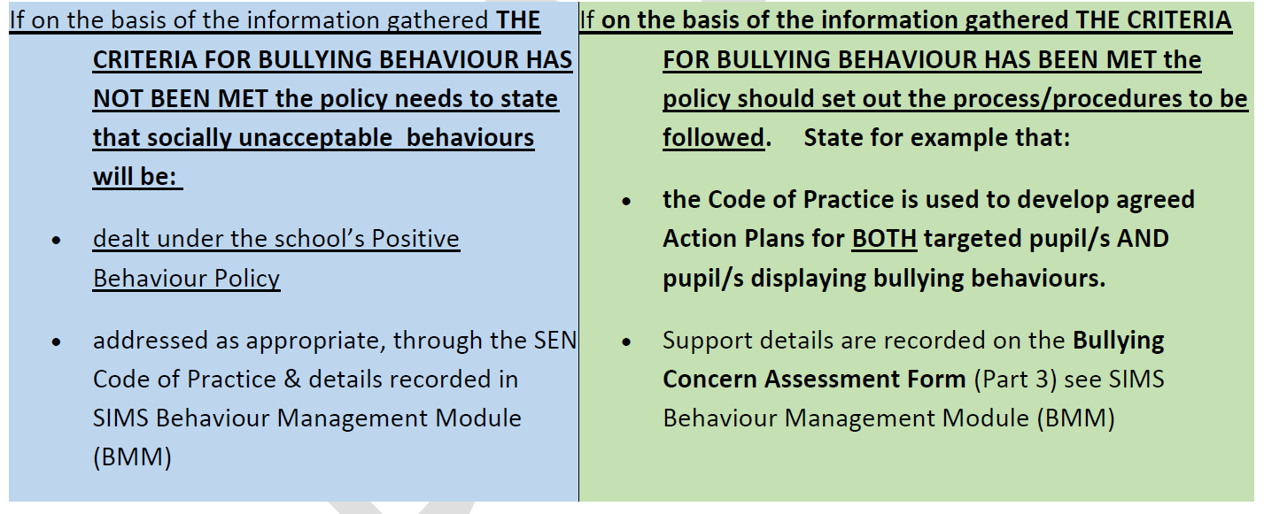
If an incident or issue is not deemed to be bullying, that will be explained to the complainant along with the reasons for that decision. The concern will be dealt with in line with the school’s positive behaviour policy.

SUPPORT PROVISIONS
The school will provide support to all involved in an incident. This may be internal and external. This support will be assessed throughout the process.
Support for targeted pupil/s would involve:
- discussing and agreeing a tailored Code of Practice action plan which would involve pupil/s in: identifying SMARTE (Specific, Measurable, Achievable, Relevant, Timely and Evidence Based) target/s; relevant success criteria, outcomes and assessment procedures
- keeping a record of the agreed action plan in Part 3 of the BCAF.
- ongoing dialogue to ensure that the strategies identified and agreed would, when implemented, result for example in: greater resilience; development of new coping skills & the promotion of positive restorative relationships – The school will use interventions contained in NIABF’s “Effective responses to bullying behaviour”, (Pgs. 16-19 Appendix 3) and following; strategies from the DE SEN Resource File, “Understanding and Managing Social, Emotional and Behavioural Difficulties” (Pgs. 272-279 Appendix 4)
- copies of the agreed plan being shared with key partners to ensure for example- clarity of roles and understanding of specific strategies.
- staff and pupils together tracking and monitoring progress to ensure the efficacy of the intervention is maintained and kept under review.
- collecting data to evaluate the efficacy of the intervention by considering the following: were appropriate targets identified; did the strategies prove effective; were strategies consistently implemented by staff and pupils; was the success criteria clear; was the success criteria met etc.?
- keeping staff and pupil-self-assessment records
- progress being regularly reviewed and updated in the BCAF, and outcomes shared with key partners – BCAF Part 4

Support for pupil/s displaying bullying behaviour would involve:
- discussing and agreeing a tailored Code of Practice action plan which would involve pupil/s in: SMARTE target/s, success criteria, outcomes and assessment procedures - see BCAF Part 3
- keeping a record of the agreed plan in Part 3 of the BCAF.
- ongoing dialogue to ensure that the interventions/strategies identified and agreed would, when implemented, result for example in: reduction/removal of unacceptable bullying behaviour/s; an enhanced ability to empathise and the restoration of relationships - using interventions contained in NIABF’s “Effective responses to bullying behaviour”, Pgs. 16-19 and following; for strategies using DE SEN Resource File, “Understanding and Managing Social, Emotional and Behavioural Difficulties” Pgs. 272-279 See Appendix
- copies of the agreed plan being shared with key partners to ensure for example clarity of roles and understanding of specific strategies,
- staff and pupils together tracking and monitoring progress to ensure the efficacy of the intervention is maintained and kept under review.
- collecting data to evaluate the efficacy of the intervention by considering the following: were appropriate targets identified; did the strategies prove effective; were strategies consistently implemented by staff and pupils; was the success criteria clear; was the success criteria met etc.?
- keeping staff and pupil-self-assessment records
- progress being regularly reviewed and updated in the BCAF, and outcomes shared with key partners BCAF Part 4
Follow-up procedures
The school will:
- report back promptly to parents/carers informing them fully of actions taken/to be taken and outcomes achieved.
- provide regular opportunities for post-incident learning (debriefing sessions) for both target/s and pupil/s displaying bullying behaviour e.g. using Worth a Rethink; Think Time Discussion Sheet
- acknowledge, affirm and celebrate success.

Section 10 – Recording
The schools will:
Keep a central (e.g., digital or paper) record of ALL bullying or alleged bullying incidents that occur while:
(a) on the premises of the school during the school day
(b) travelling to or from the school during the school term (see below point a).
(c) the pupil is in the lawful control or charge of a member of the staff of the school (see point B); or
(d) the pupil is receiving educational provision arranged on behalf of the school and provided elsewhere than on the premises of the school.
To clarify:
- how travelling to or from the school during term time is interpreted e.g., while wearing school uniform for example to travel daily directly to school at the start of the day and directly from school to home at the end of the school day when: on foot; on the school bus; on a ‘school’ taxi to an off-site educational provider
- what being under the lawful control of a member of the school staff entails - e.g., whilst on a school trip, a school visit; playing on a school team, attending another school/FE college under local Area Learning Community arrangements.
Schools when dealing with allegations of bullying behaviour are advised to use the Bullying Concern Assessment Form (BCAF Appendix 1) found on the c2k SIMS Behaviour Management Model to record details which include:
- information gathered e.g., from those involved, key bystanders
- what from the information gathered and all of the circumstances, appears to be the motivation or underlying theme behind the behaviour e.g., gender, disability, race, Looked After Status (LAC) etc.
- the method/s of bullying e.g., exclusion, verbal, electronic, physical etc.
- details about how the incident was addressed i.e., interventions selected, action taken and support provided for both target/s and the pupil/s displaying bullying behaviour/s; any external support provided together with outcomes achieved
Therefore, the school will centrally record all relevant information related to reports of bullying concerns, including:
- how the bullying behaviour was displayed (the method)
- the motivation for the behaviour
- how each incident was addressed by the school
- the outcome of the interventions employed.
Records will be kept on file in a secure location or on the online SIMS Behaviour Management Module, which is part of the C2k system in schools. Access to these records will be restricted and only provided to those members of school staff with a legitimate need to have access.
All records will be maintained in line with relevant data protection legislation and guidance and will be disposed of in line with the school’s Retention and Disposal of Documents Policy. Collated information regarding incidents of bullying and alleged bullying behaviour will be used to inform the future development of anti-bullying policy and practice within the school.

Section 11 – Professional Development of Staff
Kilbroney Integrated Primary School recognises the need for appropriate and adequate training for staff, including teaching and non-teaching school staff.
The school is committed to providing staff with appropriate opportunities for professional development as part of the school’s ongoing CPD/PRSD provision as resource and operational capacity allows. CPD records will be kept and updated regularly.
Records of training will be maintained as part of the schools in service training log.
and training will feed into policy review and procedural development.
Opportunities for safeguarding training are afforded to Governors and all staff – teaching and non-teaching.

Section 12 – Monitoring and Review of Policy
To appropriately monitor the effectiveness of the Anti-Bullying Policy, the Board of Governors shall:
- maintain a standing item on the agenda of each meeting of the Board where a report on recorded incidents of bullying will be noted.
- identify trends and priorities for action.
- assess the effectiveness of strategies aimed at preventing bullying behaviour.
- assess the effectiveness of strategies aimed at responding to bullying behaviour.
It is a legal requirement that the Anti-Bullying Policy be reviewed at intervals of no more than four years. It is our intention to review this policy within 4 years or sooner if any incident or external policy change occurs which highlights the need for such a review or if directed to by the Department of Education and in light of new guidance. The next review should therefore take place at the beginning of 2027 school year if not before.

Section 13 – Links to Other Policies
The Anti-Bullying Policy forms part of the school’s overall Pastoral Care Policy. It links with the Child Protection/Safeguarding Policy in which the school outlines the steps it will take to protect children from harm and develop their personal safety strategies.
It also links with the school’s E-Safety Policy and Positive Behaviour Policy. The school outlines the types of behaviour which are considered to be appropriate and inappropriate along with the sanctions which will be used as part of the positive behaviour promotion process.

In the development and implementation of this Anti-Bullying Policy, the Board of Governors has been mindful of related policies, including:
- Positive Behaviour Policy
- Pastoral Care Policy
- Safeguarding and Child Protection Policy
- Special Educational Needs Policy
- Health and Safety Policy
- Relationships and Sexuality Education
- E-Safety Policy & Acceptable Use of Internet Policy
- Mobile Phone Policy
- Educational Visits
- Staff Code of Conduct
The Anti-bullying Policy will need to work alongside all linked policies and ensure:
- that all socially unacceptable behaviours are managed under the Positive Behaviour Policy procedures – see current school policy for further details.
- that any Code of Practice action plans are drawn up, tracked, monitored, assessed and reviewed through the implementation of the Special Educational Needs (SEN) policy - see current school SEN policy for further details regarding procedures etc.
- that should physical restraint prove necessary it will be undertaken in compliance with the school’s Safe Handling Policy - see current policy for further details
- that incidents relating to e-safety will be managed with reference to the school’s E-safety Policy requirements – see current policy for further details.
- that further details relating to the “preventative curriculum” can be found in the statutory personal development curriculum/pastoral care policy which requires schools to give specific attention to pupils’ emotional wellbeing, health and safety, relationships, and the development of a moral thinking and value system.

The Board of Governors of Kilbroney Integrated Primary School will monitor and review the effectiveness of the Anti-Bullying Policy and will update it regularly in line with new initiatives and developments.

Signed:____________________Principal Date:

Signed:____________________Chair of Governors Date:

Appendix 1
Bullying Concern Assessment Form (BCAF)
Incident Date:
Pupils Involved | Role | Incident Date | Gender | DOB | Year and Reg

Incident | Comments
Bullying Concern

PART 1 - Assessment of Concern Date:

Addressing Bullying in Schools Act (Northern Ireland) 2016 defines bullying as follows:

“bullying” includes (but is not limited to) the repeated use of —
(a) any verbal, written or electronic communication
(b) any other act, or
(c) any combination of those,
by a pupil or a group of pupils against another pupil or group of pupils, with the intention of causing physical or emotional harm to that pupil or group of pupils.
 | Name(s) | Gender | DOB/Year Group
Person(s) reporting concern

Name of pupil(s) experiencing alleged bullying behaviour

Name of Pupil(s) demonstrating alleged bullying behaviour

Check records for previously recorded incidents

Outline of incident(s): Attach all written accounts/drawings of incident(s) completed by targeted pupil, witnesses (i.e., other pupils, staff) including date(s) of events, if known, SIMS record.
Date | Information gathered | Location (stored)

Socially unacceptable behaviour becomes bullying behaviour when, on the basis of the information gathered, the criteria listed below have been met:
The school will treat any incident which meets these criteria as bullying behaviours.
Is the behaviour intentional? | YES / NO
Is the behaviour targeted at a specific pupil or group of pupils? | YES / NO
Is the behaviour repeated? | YES / NO
Is the behaviour causing physical or emotional harm? | YES / NO
Does the behaviour involve omission? (*may not always be present) | YES / NO

One-off Incident
When determining whether a one-off incident may be classified as bullying, the school shall take into consideration the following criteria and use the information gathered to inform and guide the decision making process:

Criteria: | Information gathered:
severity and significance of the incident
evidence of pre-meditation
Significant level of physical/emotional impact on individual/s
Significant level of impact on wider school community
Status/nature of previous relationships between those involved
Records exist of previous incidents involving the individuals

YES, the above criteria have been met and bullying behaviour has occurred. | NO, the above criterial have not been met and bullying behaviour has not occurred.
The criteria having been met, proceed to complete Part 2 of this Bullying Concern Assessment Form | The criteria having not been met, proceed to record the details in the Behaviour Incident section of this Behaviour Management Module. Refer to the Positive Behaviour Policy of your school, continue to track and monitor to ensure the behaviour does not escalate.
Agreed by ___________________________
Status ____________________________
On ___/___/___
PART 2
2:1 Who was targeted by this behaviour?
Select one or more of the following:
Individual to individual 1:1 Individual to group Group to individual Group to group
2.2 In what way did the bullying behaviour present?

Select one or more of the following:

Physical (includes for example, jostling, physical intimidation, interfering with personal property,
punching/kicking
Any other physical contact which may include use of weapons)
Verbal (includes name calling, insults, jokes, threats, spreading rumours)
Indirect (includes omission, isolation, refusal to work with/talk to/play with/help others)
Electronic (through technology such as mobile phones and internet)
Written
Other Acts
Please specify:__________________________________________________-

2.3 Motivation (underlying themes): this is not a definitive list

Select one or more of the following:

Age
Appearance
Cultural
Religion
Political Affiliation
Community background
Gender Identity
Sexual Orientation
Family Circumstance (pregnancy, marital status, young carer status)
Looked After Status (LAC)
Peer Relationship Breakdown
Disability (related to perceived or actual disability)
Ability
Pregnancy
Race
Not known
Other ______________________________________________________________

Part 3a
RECORD OF SUPPORT AND INTERVENTIONS FOR PUPIL EXPERIENCING BULLYING BEHAVIOUR:
Pupil Name: Year Group/Class:
REFER TO SCHOOL ANTI-BULLYING POLICY AND TO LEVEL 1-4 INTERVENTIONS IN EFFECTIVE RESPONSES TO BULLYING BEHAVIOUR
Parent/ carer informed: Date: By whom:

Staff Involved:

Date | Stage on Code of Practice | Intervention | Success Criteria | Action taken by whom and when | Outcomes of Intervention | Review

Record of participation in planning for interventions
Pupil:

Parent/carer:

Other Agencies:

Continue to track interventions until an agreed satisfactory outcome has been achieved
RECORD OF SUPPORT AND INTERVENTIONS FOR PUPIL DISPLAYING BULLYING BEHAVIOUR:
Part 3b
Pupil Name: Year Group/Class:
REFER TO SCHOOL ANTI-BULLYING POLICY AND TO LEVEL 1-4 INTERVENTIONS IN EFFECTIVE RESPONSES TO BULLYING BEHAVIOUR
Parent/ carer informed: Date: By whom:

Staff Involved:
Date | Stage on Code of Practice | Type of Intervention | Success Criteria | Action taken by whom and when | Outcome of Intervention | Review

Record of participation in planning for interventions
Pupil:

Parent/carer:

Other Agencies:

Continue to track interventions until an agreed satisfactory outcome has been achieved

PART 4 - REVIEW OF BULLYING CONCERN AND ACTIONS TO DATE
Date of Review Meeting:
4a- Following the Review Meeting, to what extent have the success criteria been met?
1 – Fully
2 – Partially
3 – Further intervention/support required
Give details: ___________________________________________________________________________________________________________________________________________
Part 4b- If the success criteria have not been met, continue to:
Re-assess Level of Interventions and implement other strategies from an
appropriate level
Track, monitor and review the outcomes of further intervention
Keep under review the Stage of Code of Practice each pupil is on
Follow Safeguarding Policy
Seek multi-agency input (EA, Health and Social Services etc.)
Engage with Board of Governors
Agreed by:
School | Signed:  Date:
Parent | Signed:  Date:
Pupil | Signed:  Date:

Appendix 2 -PROCESS TO FOLLOW WHEN SUPPORTING YOUNG PEOPLE WHO ARE EXPERIENCING OR DISPLAYING BULLYING TYPE BEHAVIOURS
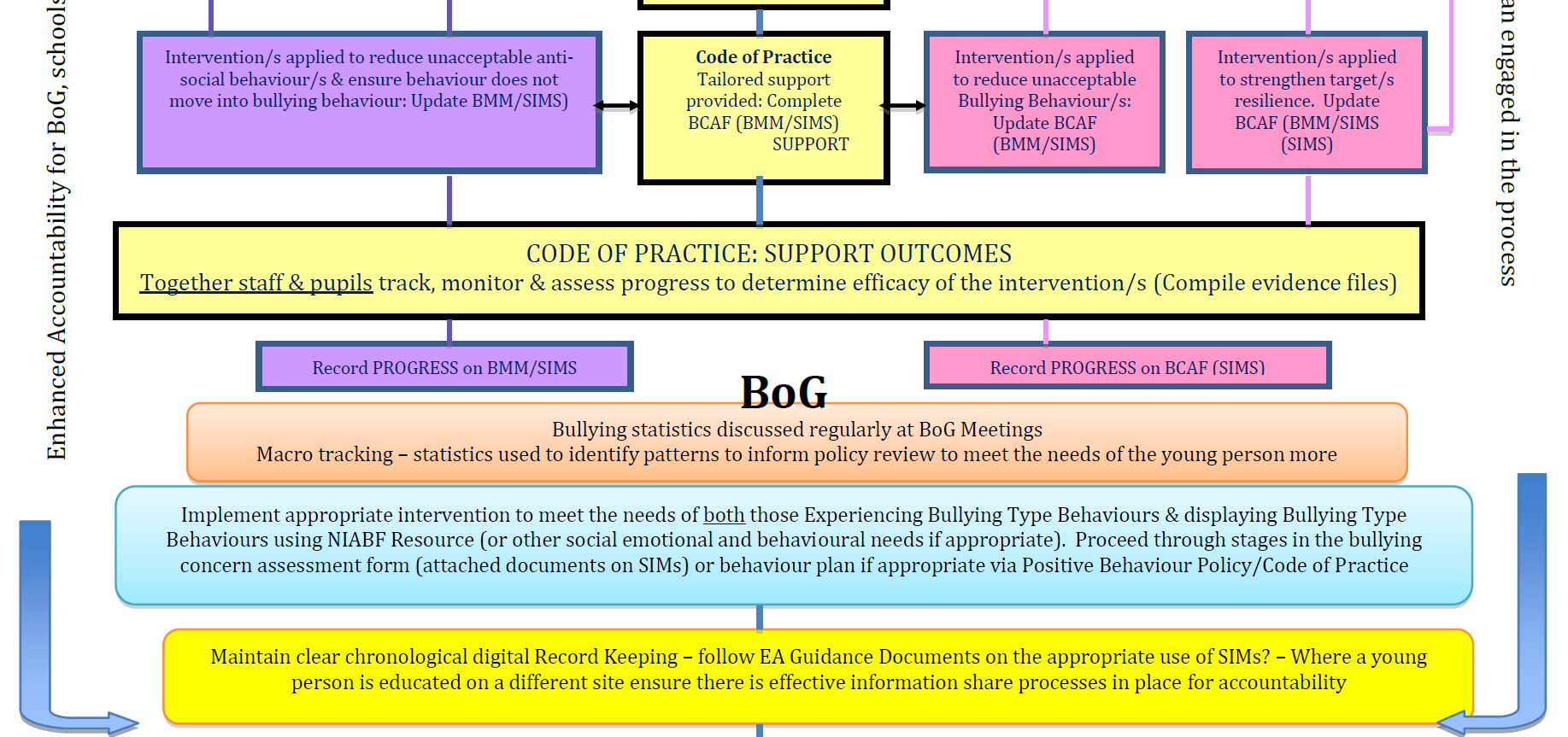
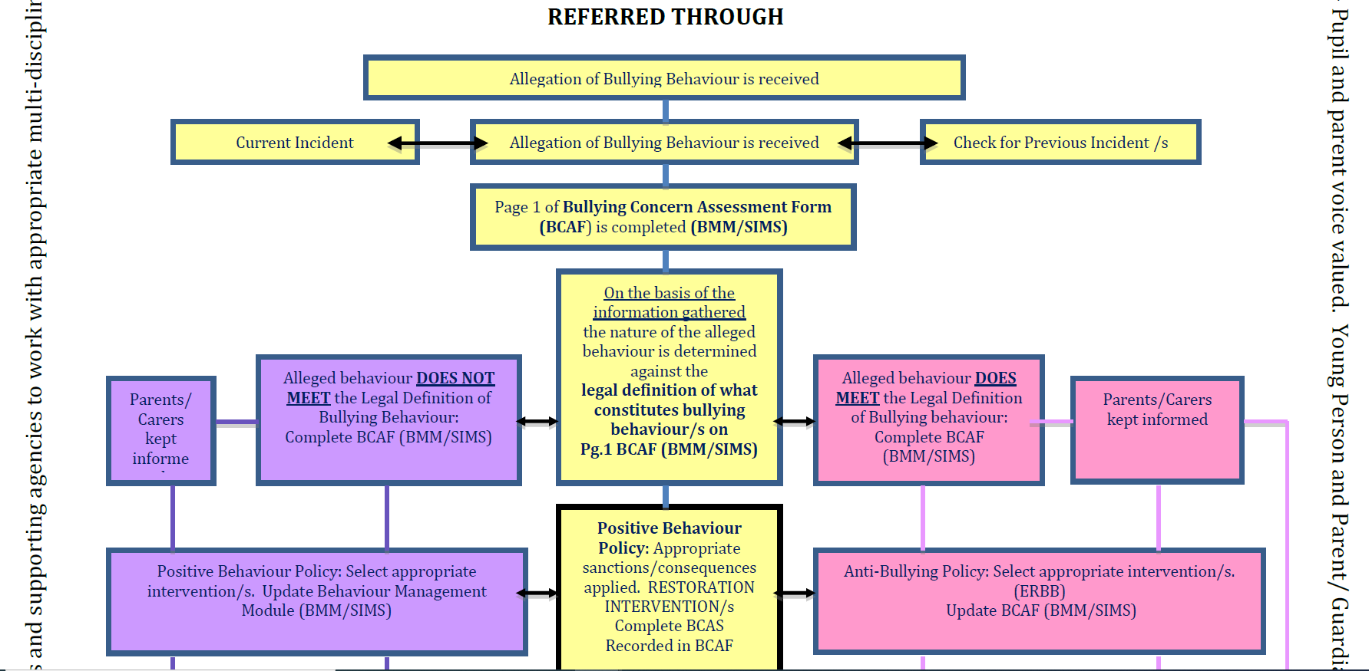
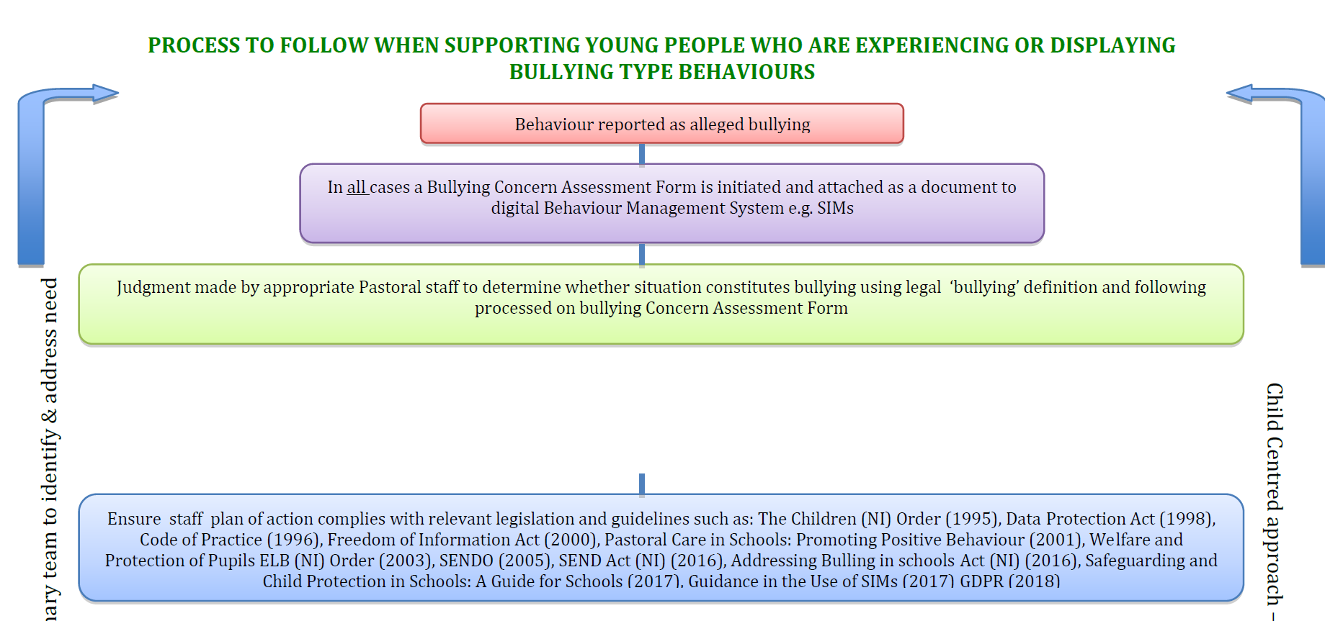

Appendix 3 Intervention tables NIABF
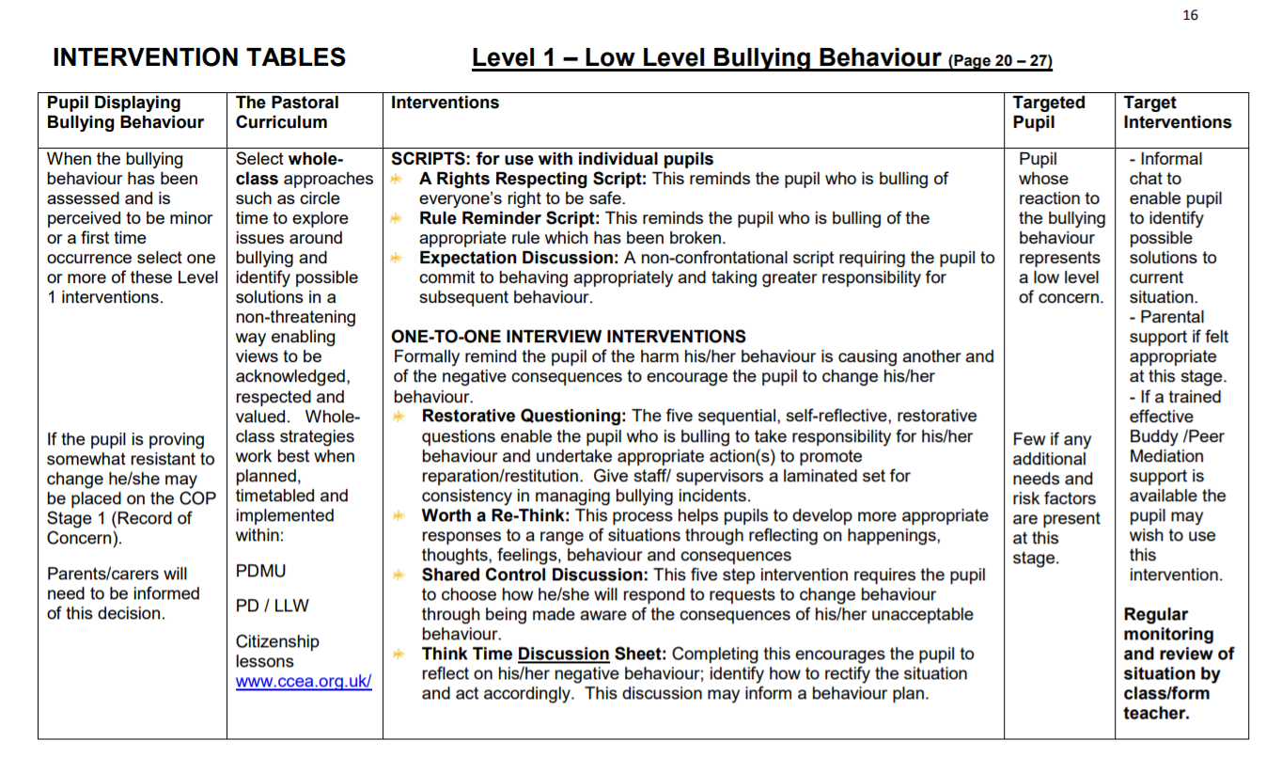
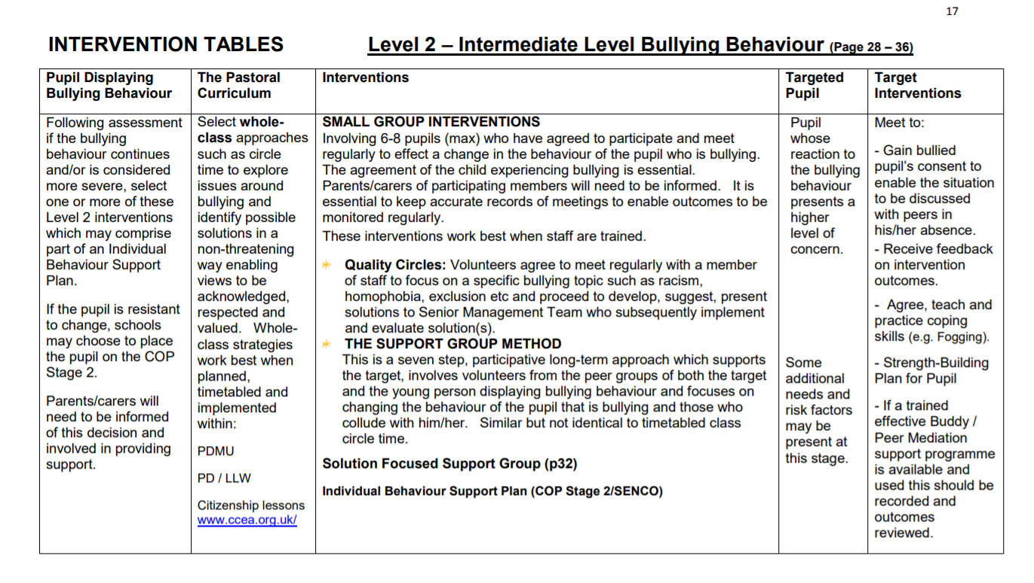
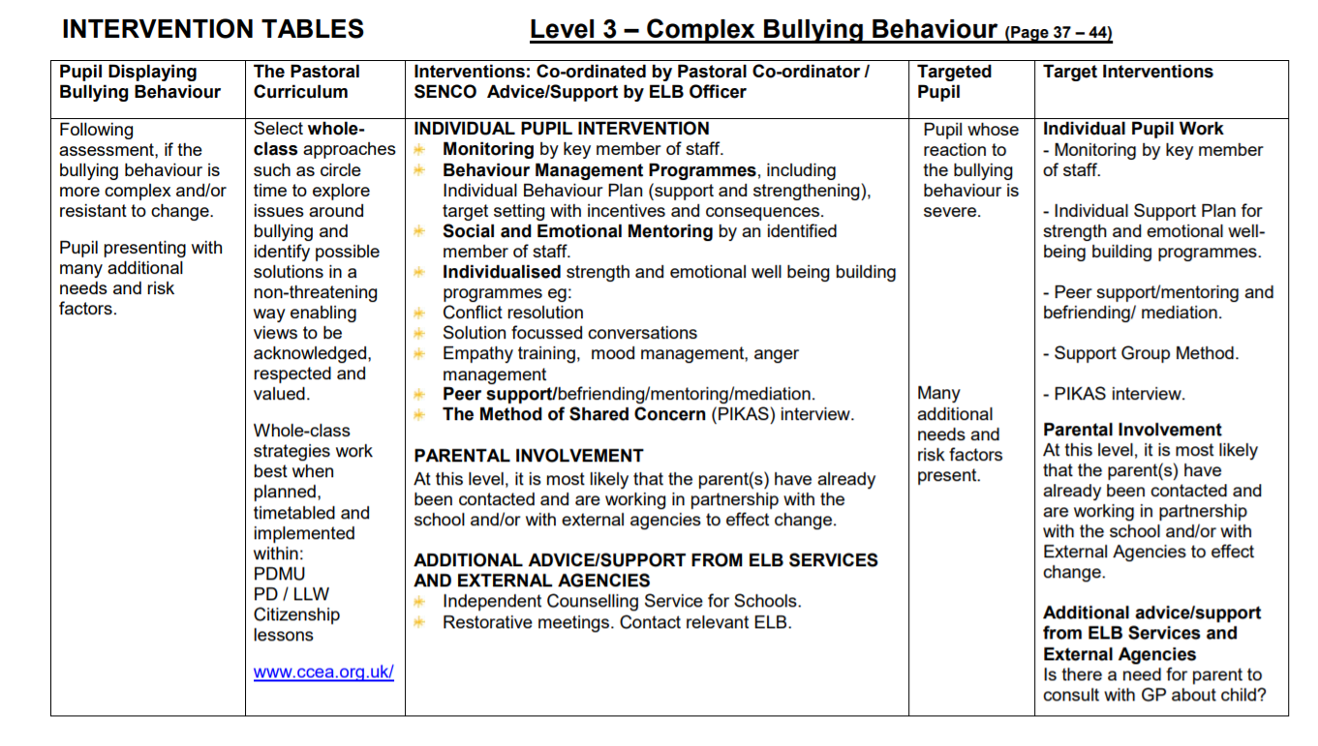
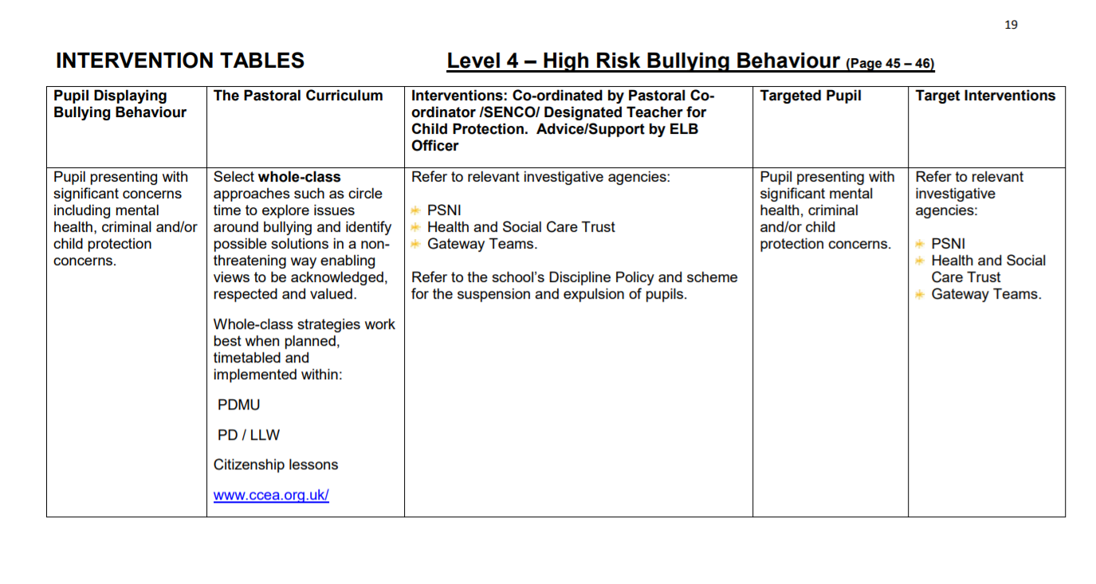

Appendix 4 Understanding & Managing Social, Emotional & Behavioural Difficulties (SEBD)
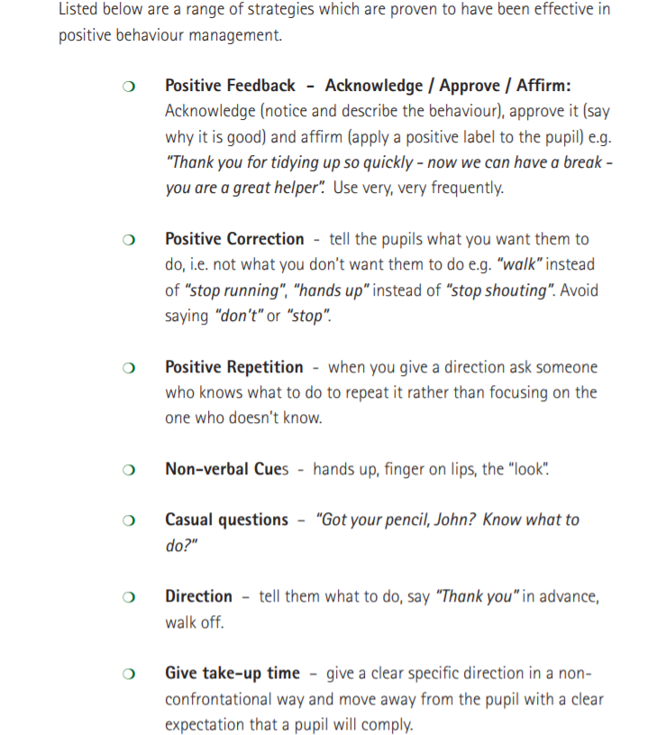
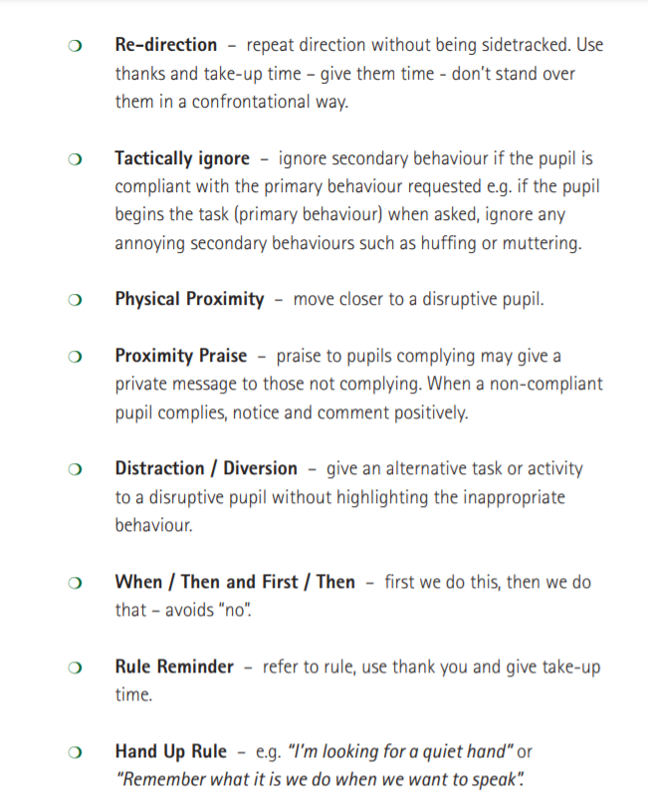
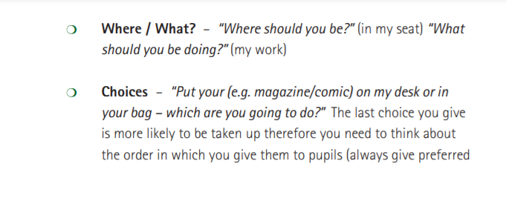

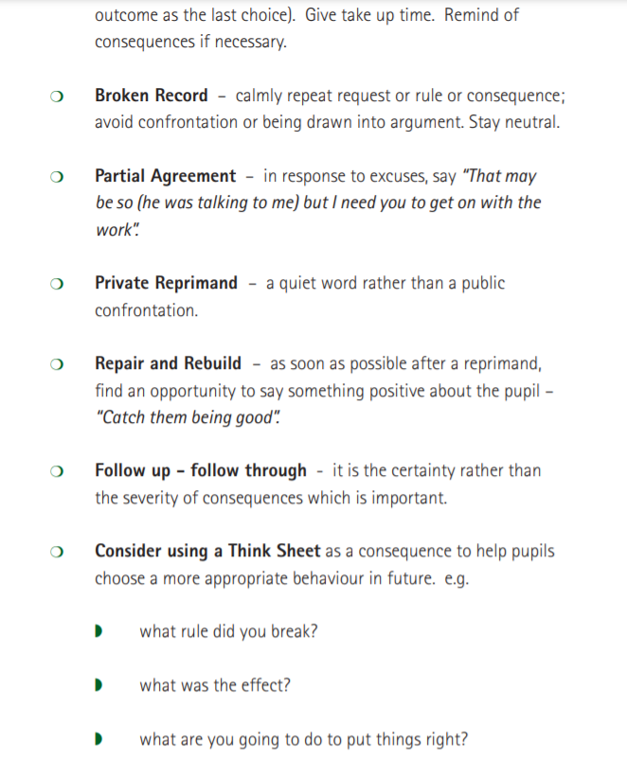

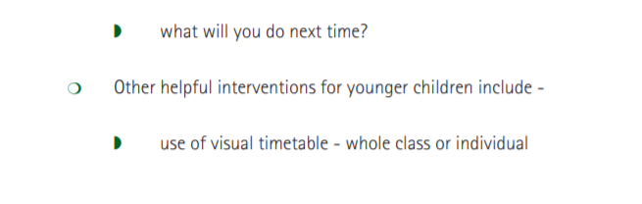
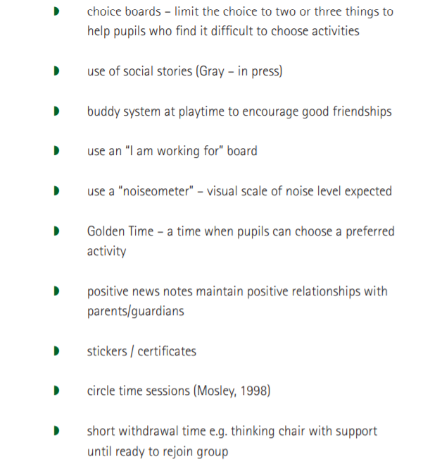
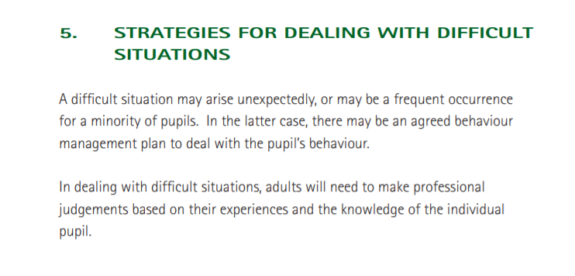
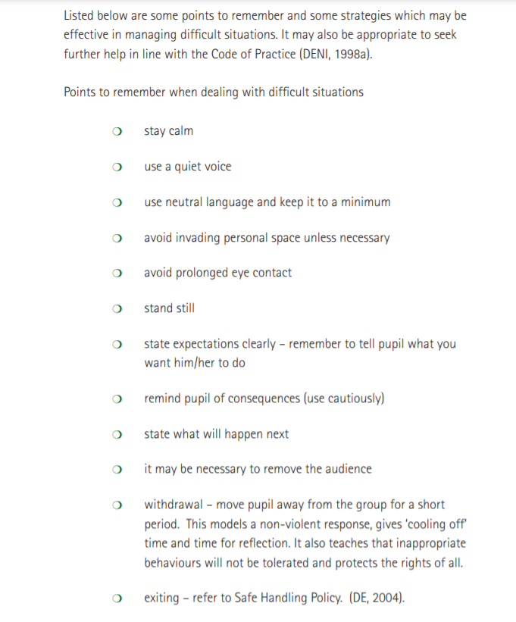
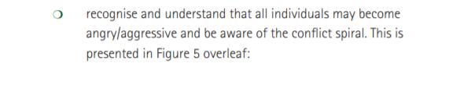
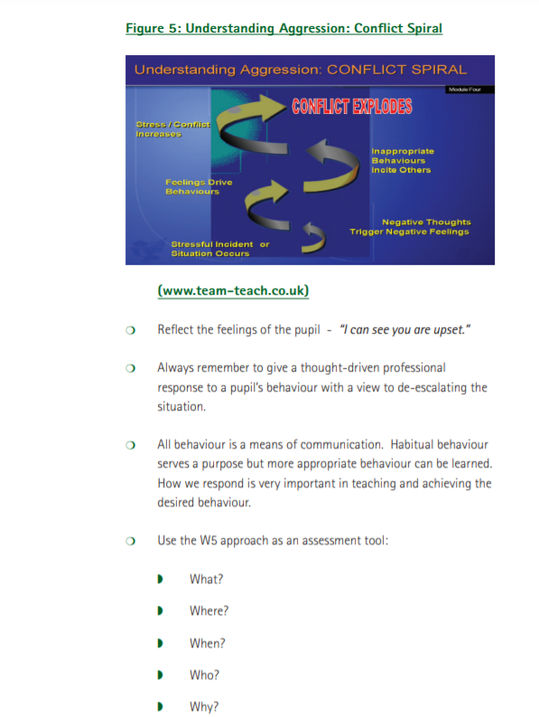

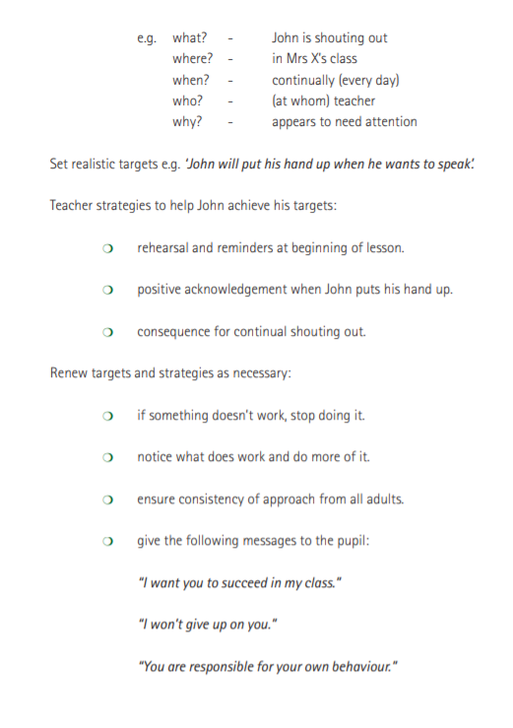
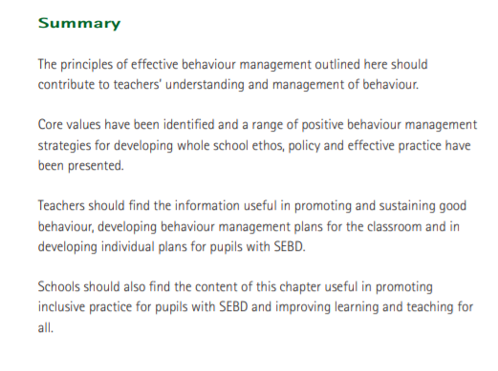

Appendix 5 Consultation documents

Anti Bullying Pupil Consultation P.1-3
What is Bullying? Bullying is behaviour that is usually repeated, which is carried out intentionally to cause hurt, harm or to adversely affect the rights and needs of another or others.

Please tick either yes or no for each question
 |  | Yes | No
1 | I feel happy at school
2 | I feel safe in school
3 | I know what to do if I feel sad.  I tell the teacher or someone in charge if someone hurts me or makes me sad.
4 | I like going outside to play
5 | I tell someone at home if someone hurts me or makes me sad at school.
6 | I try my best in school.
7 | When we do well in school, we are given stickers/rewards in class and at assembly.
8 | I can talk to my teacher about my feelings
9 | The boys and girls in my school are very good and kind.
10 | I love this school.

Thank-you for your help!
Result of Survey completed October 2023

Anti Bullying Pupil Consultation P.4-7
What is Bullying? Bullying is behaviour that is usually repeated, which is carried out intentionally to cause hurt, harm or to adversely affect the rights and needs of another or others.
Please tick true, mostly true or not true for each question
 |  | True | Mostly true | Not True
1 | I always feel happy at school
2 | Pupils in our school are well behaved
3 | Our teachers deal with incidents fairly
4 | If I tell a teacher/adult that I am the target of bullying behaviours, I know that he/she will listen and do something to help.
5 | In school we have talked about what is meant by bullying behaviour and about ways of dealing with it.
6 | If I think I have been the target of bullying behaviours, I am happy to go and talk to an adult, a teacher or a supervisor in school.
7 | Teachers and school staff help me to feel safe in school.
8 | I get on well with other pupils in my class.
9 | In class we are given opportunities to learn to respect one another, to think of others and treat everyone the same.
10 | When we do well in school we are praised either in class or at assembly.
11 | I feel safe from all forms of bullying behaviour in the playground, toilets and corridors.
12 | I know what to do if I am targeted by bullying behaviour.
13 | I understand that I must tell an adult if I or someone else is being targeted by bullying behaviours.
14 | We learn about our feelings and about bullying behaviours through assemblies, circle time, PDMU, stories, Poems Drama or through songs.
15 | If I feel like I was targeted by bullying behaviours at school, I would tell someone at home.

Thank-you for your help!

Results of survey completed October 2023
 |  | True | Mostly true | Not True
1 | I always feel happy at school | % | %
2 | Pupils in our school are well behaved | % | %
3 | Our teachers deal with incidents fairly | % | %
4 | If I tell a teacher/adult that I am the target of bullying behaviours, I know that he/she will listen and do something to help. | %
5 | In school we have talked about what is meant by bullying behaviour and about ways of dealing with it. | % | %
6 | If I think I have been the target of bullying behaviours, I am happy to go and talk to an adult, a teacher or a supervisor in school. | 1% | %
7 | Teachers and school staff help me to feel safe in school. | %
8 | I get on well with other pupils in my class. | % | %
9 | In class we are given opportunities to learn to respect one another, to think of others and treat everyone the same. | % | %
10 | When we do well in school we are praised either in class or at assembly. | % | %
11 | I feel safe from all forms of bullying behaviour in the playground, toilets and corridors. | % | % | %
12 | I know what to do if I am targeted by bullying behaviour. | % | %
13 | I understand that I must tell an adult if I or someone else is being targeted by bullying behaviours. | % | %
14 | We learn about our feelings and about bullying behaviours through assemblies, circle time, PDMU, stories, Poems Drama or through songs. | % | %
15 | If I feel like I was targeted by bullying behaviours at school, I would tell someone at home. | % | % | %

Summary

Anti Bullying Parent/Guardian Consultation
What is Bullying? Bullying is behaviour that is usually repeated, which is carried out intentionally to cause hurt, harm or to adversely affect the rights and needs of another or others.
My child’s/ children’s class………………………………..
Today’s date:……………………………………………………….
 |  | True | Mostly true | Not True
1 | The school is fully committed to creating an environment of care and trust of all pupils
2 | High standards of behaviour are expected and are evident in the school.
3 | The staff are fair, firm, consistent and compassionate in their approach to keeping good order in the school.
4 | Pupils feel able to express concerns about bullying behaviours to any member of staff, knowing that these will be received sympathetically and that appropriate action will be taken.
5 | Teachers and supervisors help my child/ren to feel safe in the playground.
6 | Good relationships between teachers, learning support and supervisors and pupils exist in and out of the classroom.
7 | Pupils are encouraged to value one another and to express their own views while appreciating the views of others.
8 | My child/ren feel secure and free from emotional and physical harm in school.
9 | The achievements of pupils are recognised, valued and celebrated so that pupil’s self-esteem is enhanced.
10 | In school pupils learn to respect and appreciate differences.
11 | In school, pupils are given opportunities to express their feelings in ways that are not aggressive.
12 | My child/ren feel/s safe from bullying behaviour in school at all times.
13 | I agree with the school’s anti bullying policy as issued.
14 | I am aware of clearly defined procedures for reporting and recording bullying behaviour incidents in school.
15 | I am confident if I have a concern about bullying that the school will deal with it quickly and effectively.

Results of Parent Consultation

Anti Bullying Parent/Guardian Consultation

Given to Parents on 25/10/23
 |  | True | Mostly true | Not True
1 | The school is fully committed to creating an environment of care and trust of all pupils | %
2 | High standards of behaviour are expected and are evident in the school. | %
3 | The staff are fair, firm, consistent and compassionate in their approach to keeping good order in the school. | %
4 | Pupils feel able to express concerns about bullying behaviours to any member of staff, knowing that these will be received sympathetically and that appropriate action will be taken. | %
5 | Teachers and supervisors help my child/ren to feel safe in the playground. | %
6 | Good relationships between teachers, learning support and supervisors and pupils exist in and out of the classroom. | %
7 | Pupils are encouraged to value one another and to express their own views while appreciating the views of others. | %
8 | My child/ren feel secure and free from emotional and physical harm in school. | %
9 | The achievements of pupils are recognised, valued and celebrated so that pupil’s self-esteem is enhanced. | % | %
10 | In school pupils learn to respect and appreciate differences. | %
11 | In school, pupils are given opportunities to express their feelings in ways that are not aggressive. | %
12 | My child/ren feel/s safe from bullying behaviour in school at all times. | %
13 | I agree with the school’s anti bullying policy as issued. | %
14 | I am aware of clearly defined procedures for reporting and recording bullying behaviour incidents in school. | %
15 | I am confident if I have a concern about bullying that the school will deal with it quickly and effectively. | %
Summary-

Kilbroney Integrated PRIMARY SCHOOL
Principal: Mrs I Porter BEd MEd CCET  E mail: iporter336@c2kni.net  Telephone: 02841738491 |  | 15 CLOUGHMORE RD  ROSTREVOR  CO. DOWN  BT34 3EL
25th October 2023
Dear Parents/Guardians,
We are seeking the views of pupils and parents/guardians to help us find out how effective our school has been in creating an Anti-Bullying culture and to review the effectiveness of our Anti-Bullying procedures.
We are presently working on preparing a revised Anti-Bullying Policy. Attached is a questionnaire that we would like you to complete. Your views would be very welcome and your responses will be treated in strictest confidence. Please complete the questionnaire and return it to school as soon as possible. The results from the survey will form part of our evaluation strategy in reviewing our Policy document.
In Kilbroney Integrated P.S our definition of bullying from our revised draft Policy is as follows:
At Kilbroney Integrated P.S we believe all forms of bullying behaviour are unacceptable. We believe that all pupils have the right to learn in a safe and supported environment.
We as a school community repudiates bullying behaviour of any kind, to any member of the school community, by any member of the school community.

The Addressing Bullying in Schools Act (NI) 2016 provides schools with a legal definition.
Addressing Bullying in Schools Definition of “bullying”:
1.—(1) In this Act “bullying” includes (but is not limited to) the repeated use
of—
(a) any verbal, written or electronic communication,
(b) any other act, or
(c) any combination of those, by a pupil or a group of pupils against another pupil or group of pupils, with the intention of causing physical or emotional harm to that pupil or group of pupils.
(2) For the purposes of subsection (1), “act” includes omission.
A statement on the definition can be seen below:
Bullying is behaviour that is usually repeated, which is carried out intentionally to cause hurt, harm or to adversely affect the rights and needs of another or others.
Please have a look at the draft policy document which you can find on the school’s website, Our School tab and click on policies. Or please contact the school for a paper copy.
Yours sincerely,

Mrs I Porter
Principal

