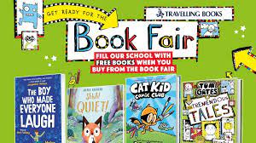

**Kilbroney Integrated Primary School**

**15 Cloughmore Road**

**Rostrevor**

**Co. Down**

**BT34 3EL**

Dear Parent

Our local TRAVELLING BOOK COMPANY is visiting the school from Thursday 23rd February to Thursday2nd March 2023.

The TRAVELLING BOOK COMPANY provides a wonderful opportunity, encouraging reading and benefiting our school by way of providing books in commission for the library and classroom. Each child will receive a £1 book voucher to use towards a purchase which will be distributed by your child’s teacher.

For further information, please visit:

<https://bookfairs.scholastic.co.uk/travelling-books/parents>

If you wish to visit this book event, it will be open from 2.00pm – 3.00pm each day.

Simply visit the fair or use the form at the bottom of this letter.

**All cheques should be made payable to the school and sent in with your order.**

Don’t forget all purchases made by you will help the school obtain more books for our library and classrooms.

To celebrate **World Book Day on Thursday 2nd March** each pupil is asked to come to school dressed as their favourite movie/book character.

Yours sincerely

I Porter

Principal

…………………………………………………………………………………………………



Name__________________________ Class_____________________

has brought £____________ to spend with THE TRAVELLING BOOK COMPANY

Signed________________________ (Parent/Guardian)