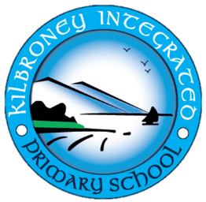

Kilbroney Integrated Primary School
15 Cloughmore Road
Rostrevor
Co. Down
BT34 3EL

30/11/2023

Dear Parent
This is a very special time of year for all our children. Christmas is about giving, coming together, being kind to each other and to most children it is about the excitement of Santa. As an integrated school we encourage our pupils to celebrate and respect all beliefs and traditions. If your child does not believe in the tradition of Santa Claus, I would ask you to please discuss with them the importance of not telling other children that Santa does not exist. Each child is entitled to believe and worship to their parents’ wishes and this must be respected by all who are affiliated with Kilbroney Integrated Primary School.
I thank you for your understanding of this delicate subject.

Yours sincerely

I Porter (Mrs)
Principal

