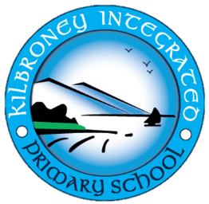

Kilbroney Integrated Primary School
15 Cloughmore Road
Rostrevor
Co. Down
BT34 3EL
01/09/2021

Dear Parent

A ten week course of swimming lessons has been arranged for P7 pupils in Newry Swimming Pool every Thursday morning beginning Thursday 9th September 2021. A bus has been organised to bring the children to and from the lessons, leaving school at 10.45am.
Please ensure your child brings their swimming gear to school on those days.

The cost of the ten-week course is £45 which includes transport and lessons. This can be paid through the Parent Pay system.

Please complete the reply slip below and return to school.

Yours sincerely

M Thompson (Mr)
Acting Principal

P7 Swimming

I give permission for my child____________________ to attend swimming lessons in Newry Swimming Pool.

I will pay £45 via Parent Pay I enclose £45

Signed _________________Parent/Guardian

