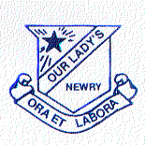
Telephone (028) 30263552
Fax No. (028) 30260140

OUR LADY’S GRAMMAR SCHOOL
CHEQUER HILL
NEWRY,
Co. DOWN BT35 6DY
22 November 2023

Dear Principal

I would like to invite you, your staff and your Primary 7 girls and their parents or carers to our Open Night which this year will be held on Tuesday 5th December 2023.

The school will be open for everyone at 7.15p.m. and I will deliver my Principal’s address at 7.30p.m. and again at 8.30p.m. in the Catherine McAuley Hall.

Entrance to the School will be via Chequer Hill and Catherine Street with parking available at Our Lady’s, St Joseph’s Convent Primary School on Catherine Street and at Newry Leisure Centre. Visitors should note that both entrances from Catherine Street and Newry Leisure Centre are via a number of steps.

I would also like to pass on my congratulations to you and your staff on the exemplary behaviour of your pupils on Saturday 11th November who sat the SEAG transfer test in Our Lady’s. They were a pleasure to have in our school and we look forward to welcoming them back this Saturday 25th.

I look forward to working with you and extend good wishes for 2024 to you, your teachers and your pupils.

Yours sincerely,
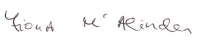

Fiona McAlinden (Mrs)
Principal

